# Lab: String Processing

This document defines the exercises for ["Java Advanced" course @ Software University](https://softuni.bg/courses/java-advanced). Please submit your solutions (source code) of all below described problems in [Judge](https://judge.softuni.bg/Contests/777).

## Student’s Results

Write a program that reads one line, containing a student’s name and his results in format **{name} - {firstResult}, {secondResult}, {thirdResult}**

Print a table on the console. Each row must contain:

* JAdv - first result, aligned right, rounded to a **precision of 2**
* OOP - second result, aligned right, rounded to a **precision of 2**
* AdvOOP - third result, aligned right, rounded to a **precision of 2**
* Average – average result, rounded to a **precision of 4**
* Columns have a **width** of **7** **characters** and must be separated with **"|"**
* Don't forget the heading row

### Examples

|  |  |
| --- | --- |
| **Input** | **Output** |
| Gosho - 3.33333, 4.4444, 5.555 | Name | JAdv|JavaOOP| AdvOOP|Average|  Gosho | 3,33| 4,44| 5,56| 4,4442| |
| Mara - 5, 4, 3 | Name | JAdv|JavaOOP| AdvOOP|Average|  Mara | 5,00| 4,00| 3,00| 4,0000| |

### Hints

It is up to you what type of data structures you will use to solve this problem

* The first row is **easy**, but long.

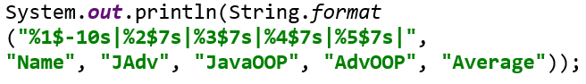

* Data rows are just a little bit more complicated:

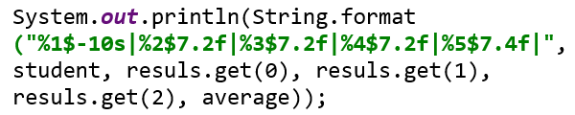

## Parse URL

Write a program that parses an URL address given in the format: **[protocol]://[server]/[resource]** and extracts from it the **[protocol]**, **[server]** and **[resource]** elements.

If the URL is not in a correct format, print “Invalid URL” on the console.

### Examples

|  |  |
| --- | --- |
| **Input** | **Output** |
| https://softuni.bg/courses/java-advanced | Protocol = https  Server = softuni.bg  Resources = courses/java-advance |
| https://www.google.bg/search?q=google&oq=goo&aqs=chrome.0.0j69i60l2://j0j69i57j69i65.2112j0j7&sourceid=chrome&ie=UTF-8 | Invalid URL |

### Hints

* **"://"** is used to show where a protocol name ends. If you have it more than once, the URL will be **invalid**.
* Server name ends with **"/"**, but it is **not** part of **resourses**.
* Resources use the same symbol **"/"** to show that we go deeper in the **folders tree**, so be careful.

Think about the proper operations over the input:

* .split()
* .substring()
* .indexOf()

## Parse Tags

You are given a text. Write a program that changes the text in all regions surrounded by the tags <**upcase**> and </**upcase**> to upper-case. The tags won’t be nested.

### Examples

|  |  |
| --- | --- |
| **Input** | **Output** |
| We are living in a <upcase>yellow submarine</upcase>. We don't have <upcase>anything</upcase> else. | We are living in a YELLOW SUBMARINE. We don't have ANYTHING else. |
| <upcase>StringBuilder</upcase> is <upcase>awesome</upcase> | STRINGBUILDER is AWESOME |

### Hints

* Be careful when **replacing** **tags** with **empty** strings.
* Consider that, after replacing a tag, the **indexes** in the string are **not** the **same**.

## Series of Letters

**Read a string** from the console and **replace** all series of **consecutive identical letters** with a **single one**.

### Examples

|  |  |
| --- | --- |
| **Input** | **Output** |
| aabb | ab |
| abc | abc |
| aaaaabbbbbcdddeeeedssaa | abcdedsa |

### Hints

* Use a quantifier for one or more repetitions +, grouping () and a backreference construct

## Vowel Count

Find the **count** of **all vowels** in a given **text** using a regex.

The vowels that you should be looking for are **upper** and **lower** case: **a**, **e**, **i**, **o**, **u** and **y**.

### Examples

|  |  |
| --- | --- |
| **Input** | **Output** |
| Abraham Lincoln | Vowels: 5 |
| In 1519 Leonardo da Vinci died at the age of 67. | Vowels: 15 |
| n vwls. | Vowels: 0 |

### Hints

* Read the input using
* Compile the pattern and create a Matcher object:



* Count the occurrences:

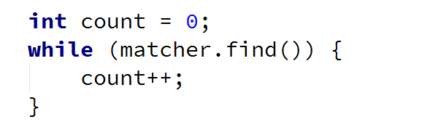

* Finally, print the result:

## Extract Tags

Read lines until you get the **"END"** command. Extract all **tags** from the given HTML using **RegEx**. If there are **no tags**, don’t print anything.

### Examples

|  |  |
| --- | --- |
| **Input** | **Output** |
| <!DOCTYPE html>  <html lang="en">  <head>  <meta charset="UTF-8">  <title>Title</title>  </head>  </html>  END | <!DOCTYPE html>  <html lang="en">  <head>  <meta charset="UTF-8">  <title>  </title>  </head>  </html> |
| No tags.  END | *(no output)* |

### Hints

* Use the special character dot "." and one of the regex quantifiers **made lazy**:

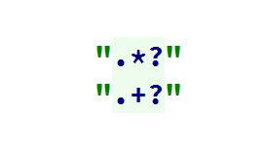

* Design your own regex to get a complete solution

## Valid Usernames

**Scan** through the lines for **valid usernames**.

A valid username:

* Has **length** between 3 and 16 characters
* **Contains** only letters, numbers, hyphens and underscores
* Has **no redundant symbols** before, after or in between

Read the lines until you get the **"END"** command. If there are **no valid usernames**, don’t print anything.

### Examples

|  |  |
| --- | --- |
| **Input** | **Output** |
| sh  too_long_username  !lleg@l ch@rs  jeff_butt  END | invalid  invalid  invalid  valid |
| END | *(no output)* |

### Hints

* Use character classes [], quantifiers {} and anchors ^ and $